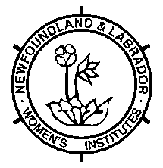 | Annual District Report  District: _______________________  1 copy to the Provincial Office via Email: nlwi@nfld.com  1 copy for your files

Please fill in below information which has not been reflected in the convenors reports.
Please note that birthdays, anniversaries, bereavements, stories, crafts, or social functions are not to be listed below as they are captured in WI newsletters.

Activities
Avalon West
Projects:
Special Thanks:
Donations:

Central Newfoundland
Projects:
Special Thanks:
Donations:

Green Bay
Projects:
Special Thanks:
Donations:

Labrador South
Projects:
Special Thanks:
Donations:

Notre Dame Bay South
Projects:
Special Thanks:
Donations:

St. John’s
Projects:
Special Thanks:
Donations:

Trinity and Bonavista
Projects:
Special Thanks:
Donations:

West Coast Newfoundland
Projects:
Special Thanks:
Donations:

